

sanef its technologies

sanef its – DIO

DIO Boards Management
Technical proposal

Distribution

Name | Company | Name | Company
N. BLANCHE | sanef its
T.CVITANIC | sanef its
J. DADIC | sanef its
J.URSIC | sanef its
Document Status

Title | Technical proposal - DIO Boards Management
Reference
Release | 1d
Owner | sanef its
Diffusion | Internal ☑ External ◻
Validation | Yes ◻ No ☑
Status | In progress ☑ | Approved ◻

Edition History

Ed / Ind | Date | Editor | Object/Description
1a | 13/11/2012 | Alen Hajdarevic | Creation
1b | 22/11/2012 | Alen Hajdarevic | Update of the document
1c | 04/12/2012 | Alen Hajdarevic | Update of the document
1d | 18/12/2012 | Alen Hajdarevic | Update of the document

Approvals

 | Name | Visa
Written by | Alen Hajdarevic
Checked by
Approved by

1. General 1
1.1 Presentation 1
1.2 Library interface 1
1.3 Development tools 1
1.4 How to maintain this document 1
1.5 The directory structure 2
1.6 Resources information 2
2. Conception 3
2.1 Architecture 3
2.2 Plug-ins (sub modules) 4
2.3 Configuration 4
2.3.1 Registry keys structure and parameters 4
2.3.1.1 [DIO] registry key 4
2.3.1.2 [PLUGINS] registry key 5
2.3.1.3 Plug-in registry keys and parameters 5
2.4 Interface 9
2.4.1 Data types 9
2.4.1.1 Input/output state 9
2.4.1.2 Error codes 9
2.4.2 Set of exported functions used on the DIO MAIN 10
2.4.2.1 Initialization of the DIO MAIN module 10
2.4.2.2 Release of the DIO MAIN module 10
2.4.2.3 Get a range of digital inputs and outputs controlled by the DIO MAIN 11
2.4.2.4 Get the state of the particular input controlled by the DIO MAIN 11
2.4.2.5 Set the state of the particular input controlled by the DIO MAIN 12
2.4.2.6 Get the state of the particular output controlled by the DIO MAIN 12
2.4.2.7 Set the state of the particular output controlled by the DIO MAIN 13
2.4.3 Set of exported functions used on PLUG-INS 13
2.4.3.1 Initialization of PLUG-IN 13
2.4.3.2 Release of PLUG-IN 14
2.4.3.3 Get a range of digital inputs and outputs controlled by plug-in 14
2.4.3.4 Get the state of the particular input controlled by plug-in 15
2.4.3.5 Get the state of the particular output controlled by plug-in 15
2.4.3.6 Set the state of the particular output controlled by plug-in 16
2.5 Simulator 16

General

Presentation
This document describes the interface used in the communication between the user application and the DIO MAIN module. Also, it describes the interface between the DIO MAIN module and PLUG-INS that communicate with DIO board\boards. Generic functions used for this communication are defined in the dio_interface.h header file. The DIO MAIN module works with DIO board/boards through sub modules (plug-ins). Each sub module (plug-in) communicates with one or more DIO boards of the same type.

Library interface
If the user application uses functions for communication with DIO board/boards it has to include the dio_interface.h header file and links to the csr_dio_main.lib library. These files contain generic functions used in the communication between the user application and the DIO MAIN module, and in the communication between the DIO MAIN and plug-ins.

Development tools
The library is developed and compiled in VC 6.0

How to maintain this document
There is only one document for one module type and for all library versions. The document is stored in the “ProjectDirectory”\DIO\DIO_MAIN\Doc folder. If library changes generate the new functions, or parameters this document should be updated with corresponding description. This description must include the version number from which exported functions, data or parameter are supported.

The directory structure
Below is description of the directory structure:

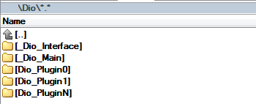

The root directory is “DIO_GEN”. The directory “_Dio_Interface” contains dio_interface.h header file. The directory “_Dio_Main” contains DIO MAIN module project, csr_dio_main.lib library and all related files. Each of sub modules has its own directory (e.g. “Dio_Contec”). This directory structure is used for easier linking and easier making of new modules release.

Resources information
To set correctly the resources information please, keep the following guidelines:
- Version of the “_Dio_Interface” module is changed only if the dio_interface.h header file is changed. Only the first digit of the version number is changed.
- All compatible modules (the DIO MAIN module and plug-ins) are linked to the same version of the “_Dio_Interface” module.
- The first digit of the version number of each sub module (plug-in) is changed only if version of the “_Dio_Interface” module is changed.
- The second and third digits of particular sub module (plug-in) are changed if there are some changes on that module.

Conception

Architecture
The DIO MAIN module is conceived as the interface between the user application and sub modules (plug-ins) which are used to communicate with the DIO board/boards. The user application is statically linked with the DIO MAIN library (csr_dio_main.lib). The DIO MAIN module dynamically loads sub modules (plug-ins). Module represents virtual DIO board made of aggregation of real DIO boards that can be from different manufacturers. Below is a diagram that describes the flow of communication between the user application and finally DIO board/boards.

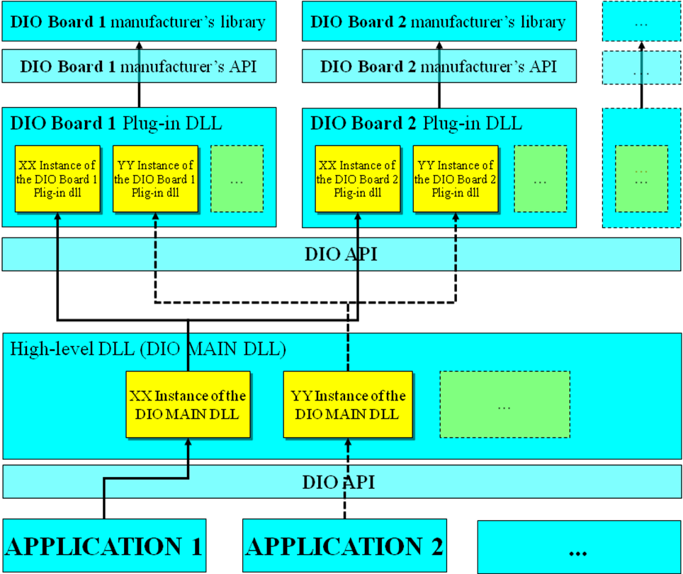

Plug-ins (sub modules)
The DIO MAIN module dynamically loads sub modules (plug-ins) calling LoadLibrary() WINAPI function. The GetProcAddress() WINAPI function is used to retrieve addresses of exported functions in sub modules (plug-ins). As it was already mentioned above, the set of exported function is defined in the dio_interface.h header file. For detailed explanation of functions used for communication between the DIO MAIN module and plug-ins please read section 2.4 of this document.
Sub module (plug-in) can communicate with one or more DIO boards if they are the same type (from the same manufacturer). Each of plug-ins (sub modules) is configurable from the registry. For more information about plug-in configuration and registry parameters please read section 2.1.1.3 of this document. Plug-in also can be used independently of the DIO MAIN module. The functions used for communication with plug-ins are explained in the section 2.4.3 of this document.

Configuration
The DIO MAIN module is configurable from the registry. Each of sub modules (plug-ins) has also its own configuration in the registry. In the following sections it will be described registry key structure and parameters in the context of configuration of the DIO MANI module.

Registry keys structure and parameters
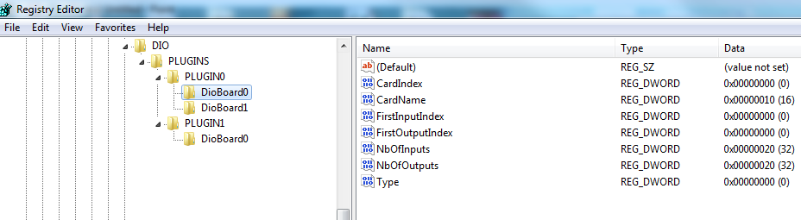

[DIO] registry key
The root DIO registry key is defined by the function MDioInit(). This function also provides the ability to keep the default path to the root DIO key. More about this function please read in the section 2.4 of this document). The default path to the root DIO key is as follows:
[HKEY_LOCAL_MACHINE\SOFTWARE\CSRoute\LaneController\Config\Modules\DIO]

Name | Type | Description
UseSimulator | dword | 1 - use simulator  0 - don’t use simulator
PLUGINS | reg. key | Plug-ins sub key

If the “UseSimulator” parameter is set to 1, the DIO MAIN module is configured to work as a simulator. In this working mode the DIO MAIN module doesn’t communicate with sub modules (plug-ins) and also there’s no communication with the DIO board.

[PLUGINS] registry key
The “PLUGINS” registry key contains all plug-ins registry keys (sub-keys of the “PLUGINS” key). Plug-in registry key is related to one type of the DIO board. Below is an example of “PLUGINS” registry key:

Name | Type |  |  | Description
PLIGUN_REG_KEY_0 |  | reg. key | Plug-in 0 (sub module) registry key
PLIGUN_REG_KEY_1 |  | reg. key | Plug-in 1 (sub module) registry key
. |  | . | .
. |  | . | .
. |  | . | .
PLIGUN_REG_KEY_N |  | reg. key | Plug-in N (sub module) registry key

The registry keys “PLIGUN_REG_KEY_0”, “PLIGUN_REG_KEY_1”, “...”, and “PLIGUN_REG_KEY_N” here are used for an example. The name of the plug-in registry key is defined by the plug-in and it can be also for example “DIO_CONTEC”. Path to the plug-in registry key (e.g. “DIO_CONTEC”) is defined by the function PDioInit() and in the context of the configuration of the DIO MANI module it depends of the path of the “DIO” registry key. The function PDioInit() provides the ability to change the path to the plug-in registry key. More about this function please read in the section 2.4 of this document).
If the path to the “DIO” registry key is next one:
[HKEY_LOCAL_MACHINE\SOFTWARE\CSRoute\LaneController\Config\Modules\DIO]
Than the path to the plug-in registry key (e.g. “DIO_CONTEC”) in the context of the configuration of the DIO MAIN module is as follows:
[HKEY_LOCAL_MACHINE\SOFTWARE\CSRoute\LaneController\Config\Modules\DIO\PLUGINS\DIO_CONTEC]

Plug-in registry keys and parameters
Each plug-in has its own configuration in the registry. This is an example of how looks plug-in registry key:
[HKEY_LOCAL_MACHINE\SOFTWARE\CSRoute\LaneController\Config\Modules\DIO\PLUGINS\ DIO_CONTEC]

Name | Type | Description
Disabled | dword | 0 – enabled  1 - disabled
dll_Name | string | Plug-in dll name
DioBoard0 | reg. key | DIO board 0
DioBoard1 | reg. key | DIO board 1
. | . | .
. | . | .
. | . | .
DioBoardN | reg. key | DIO board N

An example of the plug-in registry key:
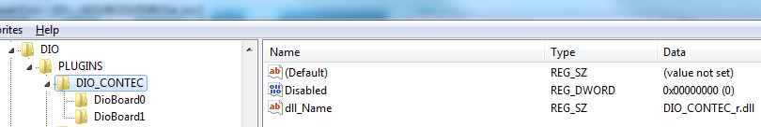

The DIO MAIN module passes through all sub keys (plug-in registry keys) and read all relevant parameters needed to properly start all of plug-ins and to properly set configuration.
The parameter “Disabled” is mandatory and defines whether the plug-in will be started or not:
“Disabled” = 1 – plug-in will not be started.
“Disabled” = 0 – plug-in will be started.
The parameter “dll_Name” is mandatory and contains the plug-in dll name used for dynamically loading of plug-in on the DIO MAIN module.
One sub module (plug-in) can communicate with more than one DIO board of the same type. Each of the DIO boards has its own registry parameters. These parameters vary depending on the type of the DIO board.

An example of the dio board registry key (sub-key of the plug-in registry key):
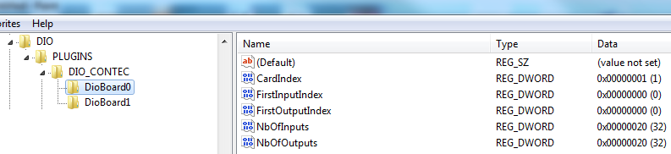

The “DioBoard0”, “DioBoard1”, ..., “DioBoardX” registry keys contain configuration of the dio boards that are managed by the plug-in.
[HKEY_LOCAL_MACHINE\SOFTWARE\CSRoute\LaneController\Config\Modules\DIO\PLUGINS\ PLIGUN_REG_KEY_0\DioBoard0]

Name | Type | Description
CardInex | dword | DIO board index
CardName | dword | DIO board name
FirstInputIndex | dword | First input index
FirstOutputIndex | dword | First output index
NbOfInputs | dword | Number of INPUTS
NbOfOutputs | dword | Number of OUTPUTS
Type | dword | DIO type

The parameters “CardName”, “CardInex“ and “Type” which are here taken as an example are specific parameters related to the specific dio board and they are not used on the DIO MAIN module. These parameters are used only on the plug-in module. There can be any other parameter specific for the particular plug-in.
In addition to these parameters explaned above, there are also parameters that are mandatory for properly configuration of the “virtual DIO board”. The DIO MAIN module actually represents “virtual DIO board”. These parameters are mandatory for all plug-ins. More explanation about these parameters hereinafter:
For the mapping inputs and outputs the plug-in uses next registry parameters placed in the registry keys of each dio board (sub-keys of the plug-in registry key):
- FirstInputIndex
- FirstOutputIndex
- NbOfInputs
- NbOfOutputs

To get a range of digital inputs and outputs the DIO MANI module uses function PDioGetRange(). More about this function please read in the section 2.4 of this document).
The parameter “NbOfInputs” represents the total number of digital inputs of the particular DIO board.
The parameter “NbOfOutputs” represents the total number of digital outputs of the particular DIO board.
The parameter “FirstInputIndex” represents “virtual” index of first digital input assigned to the particular DIO board.
The parameter “FirstOutputIndex” represents “virtual” index of first digital output assigned to the particular DIO board.
Last “virtual” input index of the particular DIO board = “FirstInputIndex” + “NbOfInputs” - 1
Last “virtual” output index of the particular DIO board=“FirstOutputIndex”+“NbOfOutputs”-1
The total number of all controlled digital inputs (by the DIO MAIN module) is equal to the sum of all “NbOfInputs” of the individual plug-ins. Also, the total number of all controlled digital outputs is equal to the sum of all “NbOfOutputs” of the individual plug-ins.

Example of how to right configure DIO boards in context of using them by the DIO MAIN module:
For this example, three DIO boards are used. Two DIO boards of the same type (from the same manufacturer - CONTEC) and one DIO board of another type (PCIDASK). The first DIO board has 32 digital inputs and 32 digital outputs. The second DIO board has 16 digital inputs and 16 digital outputs. The third DIO board also has 16 digital inputs and 16 digital outputs. The total number of the controlled digital inputs/outputs by the DIO MAIN module is equal to the sum of all digital inputs/outputs of the DIO boards.

CONTEC - The first DIO board (DIO_CONTEC\DioBoard0):
CardIndex = 1 – specific parameter for this type of the dio board
FirstInputIndex = 0; FirstOutputIndex = 0; NbOfInputs = 32; NbOfOutputs = 32;

CONTEC - The second DIO board (DIO_CONTEC\DioBoard1):
CardIndex = 0 – specific parameter for this type of the dio board
FirstInputIndex = 32; FirstOutputIndex = 32; NbOfInputs = 16; NbOfOutputs = 16;

PCIDASK - The third DIO board (DIO_PCIDASK\DioBoard0):
Adress = 47104 – specific parameter for this type of the dio board
FirstInputIndex = 48; FirstOutputIndex = 48; NbOfInputs = 16; NbOfOutputs = 16;

The total number of the controlled digital inputs by the DIO MAIN module:
X = 32(DIO_CONTEC\DioBoard0) + 16(DIO_CONTEC\DioBoard1) + 16(DIO_PCIDASK\DioBoard0) = 64
The total number of the controlled digital outputs by the DIO MAIN module:
Y = 32(DIO_CONTEC\DioBoard0) + 16(DIO_CONTEC\DioBoard1) + 16(DIO_PCIDASK\DioBoard0) = 64

If the user application, for example tries to set the state of the digital output with index 37 to 1, calls the function MDioSetOutputState() with the parameters “output index” = 37 and “state” = 1. The DIO MAIN module depending of the configuration forwards the command to a certain plug-in. In this case that is DIO_CONTEC plug-in which manages DioBoard1 digital outputs (virtual digital outputs from 32 to 48).
If the user application, for example tries to get the state of the digital input with index 45, calls the function MDioGetInputState() with parameter “input index” = 45. The DIO MAIN module depending of the configuration forwards the command to a certain plug-in. In this case that is DIO_PCIDASK plug-in which manages DioBoard0 digital inputs (virtual digital inputs from 48 to 64).

Interface
There is only one header file that defines DIO interface (dio_interface.h). Exported functions defined in the above mentioned header file enable communication between the user application and the DIO board/boards. There are two sets of functions used for this communication. First set of exported functions is used for communication between the user application and the DIO MAIN module, and second set is used for communication between the DIO MAIN module and plug-ins.

Data types

Input/output state

// INPUT/OUTPUT STATE
typedef enum
{
DIO_STATE_LOW = 0,
DIO_STATE_HIGH = 1
}
DIO_STATE;

DIO_STATE | Description
DIO _STATE_ LOW | Low state of digital input/output.
DIO_STATE_HIGH | High state of digital input/output.

Error codes
// FEEDBACK
typedef enum
{
DIO_SUCCESS = 0,
DIO_REG_KEY_MISSING,
DIO_INVALID_REG_CONFIG,
DIO_BOARD_INIT_ERROR,
DIO_INDEX_OUT_OF_RANGE,
DIO_OTHER_ERROR
}
DIO_ERROR;

DIO_ERROR | Description
DIO _SUCCESS | Successfully executed.
DIO_REG_KEY_MISSING | Registry key missing.
DIO_INVALID_REG_CONFIG | Invalid registry configuration.
DIO_BOARD_INIT_ERROR | DIO board initialization error.
DIO_INDEX_OUT_OF_RANGE | Index of digital input/output out of range.
DIO_OTHER_EROR | Other error.

Set of exported functions used on the DIO MAIN

Initialization of the DIO MAIN module
For the communication with the DIO MAIN module, the user application must first call function for initialization of DIO MAIN module:

EXPORT DIO_ERROR WINAPI MDioInit(IN HKEY hKey, IN CHAR *szRoot);

If the MDioInit() function is passed, as feedback returns DIO_SUCCESS. If the function failed, returns corresponding error code (more about error codes in the section 2.4.1.2 of this document).
The root registry key is defined by the function MDioInit(). This function also provides the ability to keep the default path to the root key.

Function parameters | Type | Description
hKey | HKEY | Handle to the registry key. This parameter is optional.  NULL = HKEY_LOCAL_MACHINE
*szRoot | CHAR | The path to the root DIO MAIN registry key. This parameter is optional.  NULL = default path to the root DIO MAIN registry key (more about default path to the root registry key please read in the section 2.3.1.1 of this document).

Release of the DIO MAIN module
The user application must call function MDioRelease() to properly release the allocated memory when the communication with the DIO MAIN module is finished:

EXPORT DIO_ERROR WINAPI MDioRelease(void);

This function has no parameters.

Get a range of digital inputs and outputs controlled by the DIO MAIN
To get a range of digital inputs and outputs controlled by the DIO MAIN module the next function is used:

EXPORT DIO_ERROR WINAPI MDioGetRange(
OUT DWORD *pdwFirstInputIndex,
OUT DWORD *pdwLastInputIndex,
OUT DWORD *pdwFirstOutputIndex,
OUT DWORD *pdwLastOutputIndex);

If the MDioGetRange() function is passed, as feedback returns DIO_SUCCESS. If the function failed, returns corresponding error code (more about error codes in the section 2.4.1.2 of this document).

Function parameters | Type | Description
*pdwFirstInputIndex | DWORD | Pointer to the variable that contains first index of digital input controlled by the DIO MAIN.
* pdwLastInputIndex | DWORD | Pointer to the variable that contains last index of digital input controlled by the DIO MAIN.
* pdwFirstOutputIndex | DWORD | Pointer to the variable that contains first index of digital output controlled by the DIO MAIN.
* pdwLastOutputIndex | DWORD | Pointer to the variable that contains last index of digital output controlled by the DIO MAIN.

Get the state of the particular input controlled by the DIO MAIN
To get current state of the particular input controlled by the DIO MAIN module, the next function is used:

EXPORT DIO_STATE WINAPI MDioGetInputState(IN DWORD dwInputIndex,
OUT DIO_ERROR *pDioErr);

Function parameters | Type | Description
dwInputIndex | DWORD | Index of digital input.
*pDioErr | DIO_ERROR | Pointer to the variable that contains error code.  If the MDioGetInputState() function is passed, as feedback returns DIO_SUCCESS. If the function failed, returns corresponding error code (more about error codes in the section 2.4.1.2 of this document).

Set the state of the particular input controlled by the DIO MAIN
This function is only meaningful if the DIO MAIN module operates in the simulation mode. Only in simulation mode, it makes sense to control the state of the inputs.

EXPORT DIO_ERROR WINAPI MDioSetInputState(IN DWORD dwInputIndex,
IN DIO_STATE eState);

If the MDioSetInputState() function is passed, as feedback returns DIO_SUCCESS. If the function failed, returns corresponding error code (more about error codes in the section 2.4.1.2 of this document).

Function parameters | Type | Description
dwInputIndex | DWORD | The index of digital input.
eState | DIO_STATE | The desired state of digital input.

Get the state of the particular output controlled by the DIO MAIN
To get current state of the particular output controlled by the DIO MAIN module, the next function is used:

EXPORT DIO_STATE WINAPI MDioGetOutputState(IN DWORD dwOutptIndex,
OUT DIO_ERROR *pDioErr);

Function parameters | Type | Description
dwOutputIndex | DWORD | Index of digital output.
*pDioErr | DIO_ERROR | Pointer to the variable that contains error code.  If the MDioGetOutputState() function is passed, as feedback returns DIO_SUCCESS. If the function failed, returns corresponding error code (more about error codes in the section 2.4.1.2).

Set the state of the particular output controlled by the DIO MAIN
To set the state of the particular output controlled by the DIO MAIN module, the next function is used:

EXPORT DIO_ERROR WINAPI MDioSetOutputState(IN DWORD dwOutptIndex,
IN DIO_STATE eState);

If the MDioSetOutputState() function is passed, as feedback returns DIO_SUCCESS. If the function failed, returns corresponding error code (more about error codes in the section 2.4.1.2 of this document).

Function parameters | Type | Description
dwOutputIndex | DWORD | Index of digital output.
eState | DIO_STATE | The desired state of digital output.

Set of exported functions used on PLUG-INS

Initialization of PLUG-IN
For the communication with plug-in, in our case the DIO MAIN module (don't remeber that plug-in can be used independently of the DIO MAIN module) must first call function for plug-in initialization:

EXPORT DIO_ERROR WINAPI PDioInit(IN HKEY hKey, IN CHAR *szRoot);

If the PDioInit() function is passed, as feedback returns DIO_SUCCESS. If the function failed, returns corresponding error code (more about error codes in the section 2.4.1.2 of this document).
The root plug-in registry key is defined by the function PDioInit(). This function also provides the ability to keep the default path to the root plug-in key.

Function parameters | Type | Description
hKey | HKEY | Handle to the registry key. This parameter is optional.  NULL = HKEY_LOCAL_MACHINE
*szRoot | CHAR | The path to the root plug-in registry key. This parameter is optional.  NULL = default path to the plug-in registry key (more about default path to the plug-in registry key please read in the section 2.3.1.2 of this document).

Release of PLUG-IN
The DIO MAIN module (in our case - don't remeber that plug-in can be used independently of the DIO MAIN module) must call function PDioRelease() to properly release the allocated memory when the communication with the plug-in is finished:

EXPORT DIO_ERROR WINAPI PDioRelease(void);

This function has no parameters.

Get a range of digital inputs and outputs controlled by plug-in
To get a range of digital inputs and outputs controlled by certain plug-in the next function is used:

EXPORT DIO_ERROR WINAPI PDioGetRange(
OUT DWORD *pdwFirstInputIndex,
OUT DWORD *pdwLastInputIndex,
OUT DWORD *pdwFirstOutputIndex,
OUT DWORD *pdwLastOutputIndex);

If the PDioGetRange() function is passed, as feedback returns DIO_SUCCESS. If the function failed, returns corresponding error code (more about error codes in the section 2.4.1.2 of this document).

Function parameters | Type | Description
*pdwFirstInputIndex | DWORD | Pointer to the variable that contains first index of digital input controlled by the certain plug-in.
* pdwLastInputIndex | DWORD | Pointer to the variable that contains last index of digital input controlled by the certain plug-in.
* pdwFirstOutputIndex | DWORD | Pointer to the variable that contains first index of digital output controlled by the certain plug-in.
* pdwLastOutputIndex | DWORD | Pointer to the variable that contains last index of digital output controlled by the certain plug-in.

Get the state of the particular input controlled by plug-in
To get current state of the particular input controlled by certain plug-in, the next function is used:

EXPORT DIO_STATE WINAPI PDioGetInputState(IN DWORD dwInputIndex,
OUT DIO_ERROR *pDioErr);

Function parameters | Type | Description
dwInputIndex | DWORD | Index of digital input.
*pDioErr | DIO_ERROR | Pointer to the variable that contains error code.  If the PDioGetInputState() function is passed, as feedback returns DIO_SUCCESS. If the function failed, returns corresponding error code (more about error codes in the section 2.4.1.2 of this document).

Get the state of the particular output controlled by plug-in
To get current state of the particular output controlled by certain plug-in, the next function is used:

EXPORT DIO_STATE WINAPI PDioGetOutputState(IN DWORD dwOutptIndex,
OUT DIO_ERROR *pDioErr);

Function parameters | Type | Description
dwOutputIndex | DWORD | Index of digital output.
*pDioErr | DIO_ERROR | Pointer to the variable that contains error code.  If the PDioGetOutputState() function is passed, as feedback returns DIO_SUCCESS. If the function failed, returns corresponding error code (more about error codes in the section 2.4.1.2 of this document).

Set the state of the particular output controlled by plug-in
To set the state of the particular output controlled by certain plug-in, the next function is used:

EXPORT DIO_ERROR WINAPI PDioSetOutputState(IN DWORD dwOutptIndex,
IN DIO_STATE eState);

If the PDioSetOutputState() function is passed, as feedback returns DIO_SUCCESS. If the function failed, returns corresponding error code (more about error codes in the section 2.4.1.2 of this document).

Function parameters | Type | Description
dwOutputIndex | DWORD | Index of digital output.
eState | DIO_STATE | The desired state of digital output.

Simulator
The DIO MAIN module can work as a simulator. To configure module to work as a simulator it is enough to set registry parameter “UseSimulator” to 1 and restart module. Where is this parameter placed in the registry is explained in the section 2.1.1.1 of this document.
If module works as a simulator it doesn’t communicate with the real DIO board/boards, but simulates the inputs and outputs. Module doesn’t load plug-ins when works as a simulator and can be used for testing, debugging and simulations on any PC without physically installed of the DIO board/boards. Rather than perform the simulation on all plug-ins it is done in one place, on the DIO MAIN module (front-end API).

